
Tertiary Infotech Academy Pte Ltd
UEN: 201200696W
LEARNER GUIDE
For
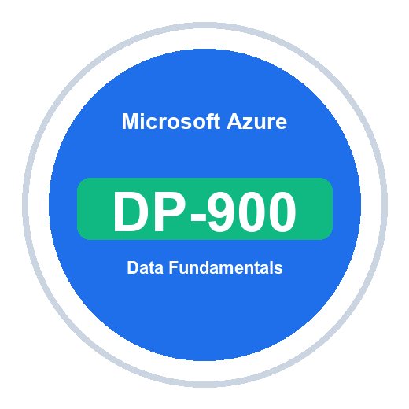
Microsoft Azure Data Fundamentals (DP-900)
TGS Ref No: TGS-2023036641
Conducted by
Tertiary Infotech Academy Pte Ltd
UEN: 201200696W
Version 1.0

DOCUMENT VERSION CONTROL RECORD
Version Number | Effective Date of Release | Summary of Included Changes | Author
1.0 | 8 July 2026 | Initial DP-900 Learner Guide aligned to all 10 labs, with Markdown mirror and step-by-step activities. | Tertiary Infotech Academy Pte Ltd

TABLE OF CONTENTS
How to Use This Guide 4
Course Details 4
Learning Outcomes 4
DP-900 Visual Maps 4
Lab Guide 6
Topic 01: Core Data Concepts 6
Lab 1: Core Data Concepts, Data Types, Workloads 6
Lab 2: Data Roles, Storage Options, File Formats 7
Topic 02: Relational Data on Azure 9
Lab 3: Relational Data, SQL, Normalization, Database Objects 9
Lab 4: Azure SQL and Open-Source Databases on Azure 10
Topic 03: Non-Relational Data on Azure 12
Lab 5: Azure Storage, Blob, Files, Tables 12
Lab 6: Azure Cosmos DB, NoSQL, APIs 14
Topic 04: Analytics Workloads on Azure 15
Lab 7: Analytics, Ingestion, Processing, Analytical Data Stores 15
Lab 8: Microsoft Fabric, Azure Databricks, Real-Time Analytics 17
Topic 05: Power BI and Exam Readiness 19
Lab 9: Power BI, Data Models, Visualizations 19
Lab 10: DP-900 Capstone and Exam Readiness 20
Assessment Flow 23

How to Use This Guide
This Learner Guide supports Microsoft Azure Data Fundamentals (DP-900) (TGS-2023036641). Work through the labs in order and use each validation section before moving on.
Course registration: https://www.tertiarycourses.com.sg/wsq-microsoft-azure-data-fundamentals-dp-900.html
Lab repository: https://github.com/tertiarycourses/TGS-2023036641---Microsoft-Azure-Data-Fundamentals-DP-900-Course-Code-TGS-2023036641

Course Details
Item | Details
Course Title | Microsoft Azure Data Fundamentals (DP-900)
Course Code | TGS-2023036641
Training Provider | Tertiary Infotech Academy Pte Ltd (UEN: 201200696W)
Duration | 2 days, 16 training hours
Labs | 10 guided labs aligned to DP-900 fundamentals
Assessment | Written Assessment and Practical Performance, open book

Learning Outcomes
- Describe structured, semi-structured and unstructured data.
- Compare transactional and analytical workloads.
- Identify common data roles and data store options.
- Explain relational concepts, SQL, normalization and database objects.
- Describe Azure SQL and open-source database services on Azure.
- Describe Azure Storage, Azure Cosmos DB and NoSQL patterns.
- Explain ingestion, processing, analytical data stores, batch and streaming analytics.
- Describe Microsoft Fabric, Azure Databricks, real-time analytics and Power BI concepts.
- Match data scenarios to appropriate Azure data services for DP-900 exam readiness.

Environment Setup
- Sign in to the Azure portal or Microsoft Learn sandbox provided by your instructor.
- Open Azure Cloud Shell when CLI commands are required.
- Use free tiers, trials and sample datasets where possible.
- Do not upload confidential or personal data into training resources.
- Clean up resources at the end of class unless the trainer instructs otherwise.

DP-900 Visual Maps
DP-900 Topic Learning Path
Topic 01 | Topic 02 | Topic 03 | Topic 04 | Topic 05
Core Data  Concepts  Labs 1-2 | Relational  Data  Labs 3-4 | Non-relational  Data  Labs 5-6 | Analytics  Workloads  Labs 7-8 | Power BI +  Exam Readiness  Labs 9-10
The following diagrams show how the labs connect the DP-900 concepts into an end-to-end data platform and service-recognition map.
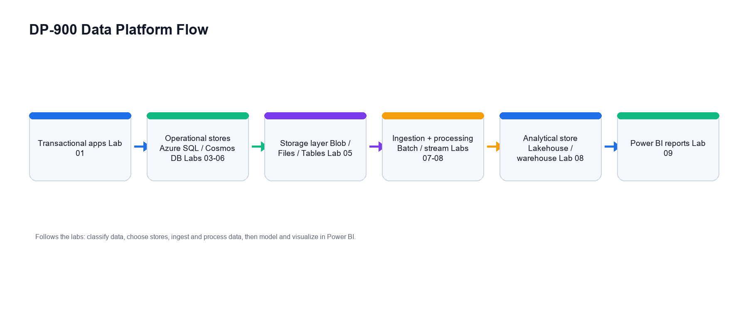
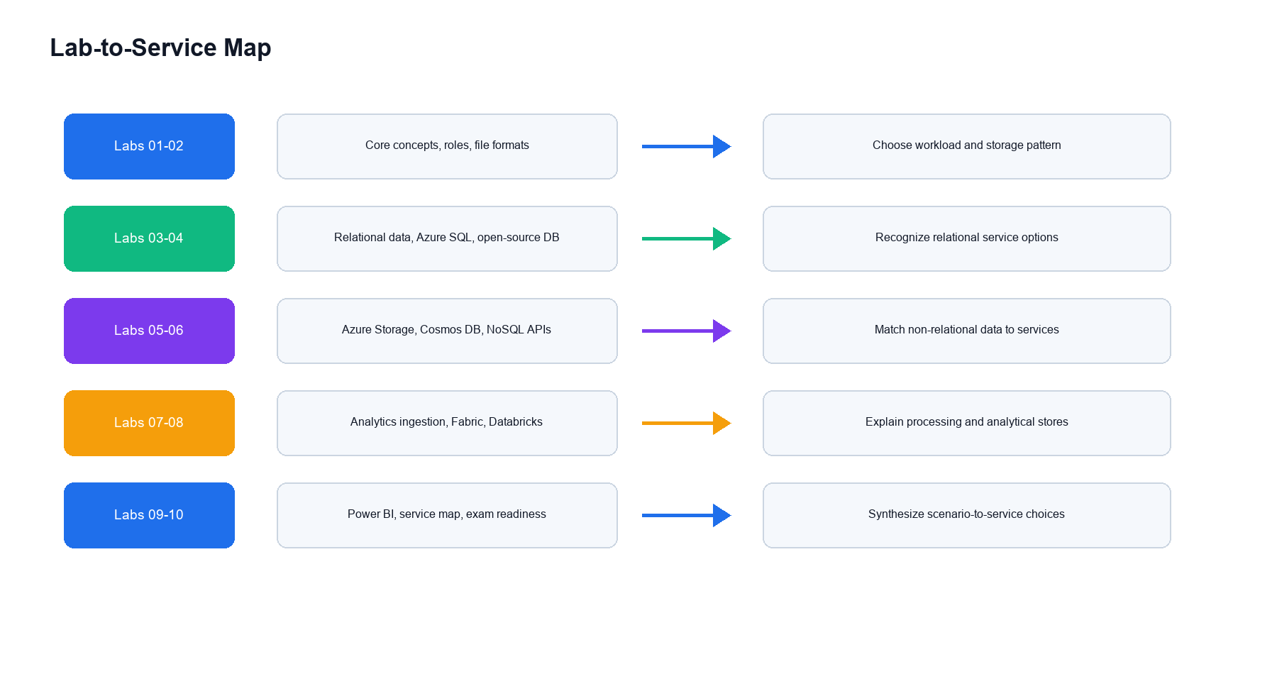

Lab Guide

Topic 01: Core Data Concepts
Data types, workloads, roles, stores and file formats

Lab 1: Core Data Concepts, Data Types, Workloads
Objectives | Guided Activities | Learner Output | Exam Focus
Read what the lab is meant to prove. | Complete each numbered task in order. | Keep the tables, notes, diagrams and answers. | Use the checkpoint questions for review.
Objectives:
- Distinguish structured, semi-structured, and unstructured data.
- Compare transactional and analytical workloads.
- Identify common data store use cases.
- Build a data concepts glossary.
Scenario:
A retail company stores sales transactions, customer profiles, product images, web logs, invoices, and analytics reports. You must classify the data and decide which workloads are transactional or analytical.
Step-by-step:
- Classify Data Types
Create a table:
Data Example | Type | Reason
Sales order table | Structured | Fixed rows and columns
JSON web event | Semi-structured | Flexible fields with structure
Product photo | Unstructured | Binary media file
Add at least five more examples.
- Compare Workloads
Create a table:
Workload | Purpose | Example
Transactional | Supports day-to-day operations | Online order processing
Analytical | Supports reporting and insight | Monthly sales trend analysis
- Identify Workload Characteristics
For each scenario, choose transactional or analytical:
1. Insert a customer order.
2. Update inventory quantity.
3. Analyze five years of sales data.
4. Create a Power BI dashboard.
5. Stream click events for real-time monitoring.
- Create a Glossary
Define:
Database
Table
File
Data lake
Data warehouse
Transactional workload
Analytical workload
Validation:
You should have a data type table, workload table, classification answers, and glossary.
Checkpoint Questions:
- What is structured data?
- What is semi-structured data?
- Why is unstructured data common in modern systems?
- How does an analytical workload differ from a transactional workload?
Exam Focus: DP-900 frequently tests the difference between data representations and workload types.

Lab 2: Data Roles, Storage Options, File Formats
Objectives | Guided Activities | Learner Output | Exam Focus
Read what the lab is meant to prove. | Complete each numbered task in order. | Keep the tables, notes, diagrams and answers. | Use the checkpoint questions for review.
Objectives:
- Identify data workload roles and responsibilities.
- Compare common file formats.
- Match storage options to use cases.
- Understand common data store categories.
Scenario:
The retail company is forming a data team. Management asks which people and services are needed for databases, pipelines, analytics, and reports.
Step-by-step:
- Identify Data Roles
Create a table:
Role | Main Responsibility
Database administrator | Manage database availability, performance, backup, and security
Data engineer | Build data pipelines and prepare data for analytics
Data analyst | Build reports, models, and insights
Add examples of tasks for each role.
- Compare File Formats
Format | Common Use
CSV | Simple tabular exchange
JSON | Semi-structured API and event data
Parquet | Columnar analytics data
XML | Structured document exchange
Avro | Data serialization in pipelines
- Match Storage Options
Requirement | Possible Store
Store images and backups | Blob storage
Shared file access | Azure Files
Key-value style entities | Azure Table Storage
Relational application database | Azure SQL Database
Globally distributed NoSQL app | Azure Cosmos DB
Large-scale analytics | Data lake, warehouse, Fabric lakehouse
- Draw a Simple Data Platform
Use diagrams.net:
Source systems -> Ingestion -> Storage -> Processing -> Analytics -> Visualization
- Record Service Selection Rules
Write one sentence for when to use relational, non-relational, object storage, and analytical stores.
Validation:
You should have role notes, file format comparison, storage mapping, and a platform diagram.
Checkpoint Questions:
- What does a data engineer do?
- Why is Parquet common in analytics?
- When would Blob storage be appropriate?
- Why do analytics platforms separate storage and compute?
Exam Focus: Know the roles and responsibilities for data workloads and common storage formats.

Topic 02: Relational Data on Azure
Relational design, SQL, Azure SQL and open-source databases

Lab 3: Relational Data, SQL, Normalization, Database Objects
Objectives | Guided Activities | Learner Output | Exam Focus
Read what the lab is meant to prove. | Complete each numbered task in order. | Keep the tables, notes, diagrams and answers. | Use the checkpoint questions for review.
Objectives:
- Explain relational data concepts.
- Identify tables, rows, columns, keys, and relationships.
- Understand normalization.
- Recognize common SQL statements and database objects.
Scenario:
The retail company stores customers, orders, products, and order lines in a relational database. You must explain how the data is structured and queried.
Step-by-step:
- Draw a Relational Model
Create entities:
Customers
Orders
OrderItems
Products
Add primary keys and foreign keys.
- Explain Normalization
Answer:
1. Why should product data not be repeated on every order line?
2. How do separate tables reduce update errors?
3. What is the tradeoff of normalization?
- Identify SQL Statement Types
Create a table:
SQL Statement | Purpose
SELECT | Read data
INSERT | Add data
UPDATE | Modify data
DELETE | Remove data
CREATE | Create objects
- Review Database Objects
Define:
Table
View
Index
Stored procedure
Schema
Primary key
Foreign key
- Write Example Queries
SELECT ProductName, Price
FROM Products;
SELECT c.CustomerName, o.OrderDate
FROM Customers c
JOIN Orders o ON c.CustomerID = o.CustomerID;
Validation:
You should have a relational diagram, normalization notes, SQL table, object definitions, and example queries.
Checkpoint Questions:
- What is a primary key?
- What is a foreign key?
- Why is normalization used?
- What does SELECT do?
Exam Focus: DP-900 expects recognition of relational concepts and common SQL statements, not advanced SQL programming.

Lab 4: Azure SQL and Open-Source Databases on Azure
Objectives | Guided Activities | Learner Output | Exam Focus
Read what the lab is meant to prove. | Complete each numbered task in order. | Keep the tables, notes, diagrams and answers. | Use the checkpoint questions for review.
Objectives:
- Describe the Azure SQL family.
- Compare Azure SQL Database, Azure SQL Managed Instance, and SQL Server on Azure VMs.
- Identify open-source database services on Azure.
- Match relational services to scenarios.
Scenario:
The retail company wants to migrate existing relational databases to Azure. Some apps use SQL Server, while others use PostgreSQL and MySQL.
Step-by-step:
- Compare Azure SQL Options
Service | Best Fit
Azure SQL Database | Modern cloud app needing managed PaaS database
Azure SQL Managed Instance | SQL Server compatibility with managed service benefits
SQL Server on Azure VMs | Maximum OS and instance-level control
- Compare Open-Source Database Services
Document:
Azure Database for PostgreSQL
Azure Database for MySQL
Azure Database for MariaDB legacy considerations
- Match Migration Scenarios
Choose a service:
1. New cloud-native app using SQL Server engine.
2. Existing SQL Server app needing instance-level compatibility.
3. Legacy app requiring OS-level control.
4. Web app using PostgreSQL.
5. App using MySQL.
- Review Managed Service Benefits
Write how managed database services help with:
- Patching.
- Backup.
- High availability.
- Scaling.
- Monitoring.
- Security.
- Security and Cost Notes
Document:
Authentication
Firewall or private access
Backup retention
Performance tier
Scaling choice
Validation:
You should have comparison tables, scenario answers, managed service benefits, and security/cost notes.
Checkpoint Questions:
- When is Azure SQL Database appropriate?
- Why choose SQL Server on Azure VMs?
- What is a managed database service?
- Which Azure services support PostgreSQL and MySQL?
Exam Focus: Know the Azure relational database service families and when each option fits.

Topic 03: Non-Relational Data on Azure
Azure Storage, Blob, Files, Tables and Cosmos DB

Lab 5: Azure Storage, Blob, Files, Tables
Objectives | Guided Activities | Learner Output | Exam Focus
Read what the lab is meant to prove. | Complete each numbered task in order. | Keep the tables, notes, diagrams and answers. | Use the checkpoint questions for review.
Objectives:
- Describe Azure Blob Storage.
- Describe Azure Files.
- Describe Azure Table Storage.
- Match storage services to scenarios.
- Review access tiers and redundancy concepts.
Scenario:
The retail company needs to store product images, shared documents, application logs, and simple key-value data.
Step-by-step:
- Map Storage Needs
Requirement | Azure Storage Service
Product images | Blob Storage
Shared file share | Azure Files
Simple key-value customer preferences | Table Storage
Queue messages | Azure Queue Storage
- Review Blob Storage Concepts
Define:
Container
Blob
Block blob
Access tier
Lifecycle management
- Review Azure Files Concepts
Explain:
- SMB and NFS file shares.
- Lift-and-shift file server scenarios.
- Shared access for applications.
- Review Table Storage Concepts
Explain:
- Partition key.
- Row key.
- Entity.
- Schemaless design.
- Compare Redundancy
Write a short note on locally redundant, zone-redundant, and geo-redundant storage.
Validation:
You should have storage mappings, concept definitions, and redundancy notes.
Checkpoint Questions:
- When should you use Blob Storage?
- When should you use Azure Files?
- What is Azure Table Storage?
- Why does redundancy matter?
Exam Focus: DP-900 expects recognition of Azure Storage services and their common use cases.

Lab 6: Azure Cosmos DB, NoSQL, APIs
Objectives | Guided Activities | Learner Output | Exam Focus
Read what the lab is meant to prove. | Complete each numbered task in order. | Keep the tables, notes, diagrams and answers. | Use the checkpoint questions for review.
Objectives:
- Explain non-relational data concepts.
- Describe Azure Cosmos DB capabilities.
- Identify common Cosmos DB APIs.
- Match NoSQL patterns to scenarios.
Scenario:
The retail company wants a globally distributed product catalog and user profile store that can handle flexible schemas and low-latency reads.
Step-by-step:
- Explain NoSQL Fit
Write why NoSQL can help with:
- Flexible schema.
- High scale.
- Global distribution.
- Low-latency access.
- JSON document data.
- Review Cosmos DB Capabilities
Document:
Global distribution
Low latency
Throughput with request units
Partitioning
Consistency levels
Multiple APIs
- Identify Cosmos DB APIs
Create a table:
API | Common Fit
NoSQL | JSON document applications
MongoDB | MongoDB-compatible apps
Cassandra | Wide-column workloads
Gremlin | Graph workloads
Table | Key-value/table workloads
- Design a Product Catalog Document
Create example JSON:
{
"id": "P1001",
"category": "Laptop",
"name": "Training Laptop",
"price": 1200,
"tags": ["business", "portable"]
}
- Review Partitioning
Explain why a good partition key distributes data and workload evenly.
Validation:
You should have NoSQL notes, Cosmos DB capability notes, API mapping, sample document, and partition key explanation.
Checkpoint Questions:
- When is Cosmos DB a good fit?
- What is a request unit?
- Why does partitioning matter?
- Which API supports graph workloads?
Exam Focus: Know Cosmos DB capabilities, APIs, and common NoSQL use cases.

Topic 04: Analytics Workloads on Azure
Ingestion, processing, analytical stores, Fabric, Databricks and real-time analytics

Lab 7: Analytics, Ingestion, Processing, Analytical Data Stores
Objectives | Guided Activities | Learner Output | Exam Focus
Read what the lab is meant to prove. | Complete each numbered task in order. | Keep the tables, notes, diagrams and answers. | Use the checkpoint questions for review.
Objectives:
- Describe analytics workload stages.
- Explain data ingestion and processing.
- Compare batch and streaming.
- Identify analytical data stores.
- Map services to analytics scenarios.
Scenario:
The retail company wants daily sales reports, customer behavior analytics, and near-real-time alerting from web clickstream data.
Step-by-step:
- Map an Analytics Pipeline
Create a flow:
Data sources
Ingestion
Raw storage
Transformation
Analytical store
Semantic model
Visualization
- Compare Batch and Streaming
Mode | Description | Example
Batch | Processes data in groups on a schedule | Daily sales summary
Streaming | Processes events continuously | Live website activity
- Identify Analytical Stores
Document:
Data lake
Data warehouse
Lakehouse
Semantic model
- Choose Azure Services
Need | Possible Service
Data ingestion and orchestration | Data Factory or Fabric Data Factory
Big data processing | Azure Databricks
Lakehouse analytics | Microsoft Fabric
Real-time event processing | Event Hubs, Stream Analytics, Fabric Real-Time Intelligence
Visualization | Power BI
- Review Data Transformation
Explain the difference between raw, cleaned, curated, and aggregated data.
Validation:
You should have pipeline diagram, batch/streaming comparison, analytical store notes, and service mapping.
Checkpoint Questions:
- What is data ingestion?
- What is the difference between batch and streaming?
- What is a data warehouse?
- What is a lakehouse?
Exam Focus: DP-900 analytics questions test high-level pipeline patterns and service selection.

Lab 8: Microsoft Fabric, Azure Databricks, Real-Time Analytics
Objectives | Guided Activities | Learner Output | Exam Focus
Read what the lab is meant to prove. | Complete each numbered task in order. | Keep the tables, notes, diagrams and answers. | Use the checkpoint questions for review.
Objectives:
- Describe Microsoft Fabric at a high level.
- Describe Azure Databricks use cases.
- Identify real-time analytics services.
- Match analytics services to scenarios.
Scenario:
The retail company is comparing analytics platforms for reporting, data engineering, machine learning, and real-time dashboards.
Step-by-step:
- Review Microsoft Fabric Concepts
Document:
OneLake
Lakehouse
Warehouse
Data Factory
Real-Time Intelligence
Power BI
- Review Azure Databricks Concepts
Explain how Databricks can support:
- Apache Spark processing.
- Data engineering notebooks.
- Machine learning workloads.
- Delta Lake patterns.
- Collaborative analytics.
- Identify Real-Time Analytics
Match:
Requirement | Possible Service
Ingest event streams | Event Hubs
Process streaming data | Stream Analytics
Real-time analytics in Fabric | Real-Time Intelligence
Visualize live metrics | Power BI real-time dashboards
- Compare Services
Create a decision table:
Scenario | Better Fit
Business reporting workspace | Microsoft Fabric
Spark-heavy engineering workloads | Azure Databricks
Simple stream processing | Azure Stream Analytics
Event ingestion at scale | Event Hubs
- Draw an Analytics Architecture
Point of sale -> Event stream -> Real-time processing -> Dashboard
Daily exports -> Lakehouse -> Transformations -> Power BI report
Validation:
You should have Fabric notes, Databricks notes, real-time service mapping, and architecture diagram.
Checkpoint Questions:
- What is Microsoft Fabric?
- What is Azure Databricks commonly used for?
- What is real-time analytics?
- Which service can ingest event streams?
Exam Focus: Know the high-level purpose of Fabric, Databricks, and Microsoft real-time analytics services.

Topic 05: Power BI and Exam Readiness
Models, visualizations, service mapping and capstone review

Lab 9: Power BI, Data Models, Visualizations
Objectives | Guided Activities | Learner Output | Exam Focus
Read what the lab is meant to prove. | Complete each numbered task in order. | Keep the tables, notes, diagrams and answers. | Use the checkpoint questions for review.
Objectives:
- Describe Power BI capabilities.
- Explain data models and semantic models.
- Choose appropriate visualizations.
- Build a simple report plan.
Scenario:
The retail company wants a dashboard for sales, products, regions, and trends. You must explain how Power BI supports data analysis.
Step-by-step:
- Identify Power BI Components
Document:
Power BI Desktop
Power BI service
Dataset or semantic model
Report
Dashboard
Workspace
Data refresh
- Design a Simple Data Model
Create tables:
Sales
Products
Customers
Dates
Regions
Identify relationships and keys.
- Choose Visualizations
Question | Visualization
Sales by month | Line chart
Sales by product category | Bar chart
Sales by region | Map or filled map
Market share by category | Donut chart or treemap
Detailed sales records | Table
- Add Measures and Filters
Define examples:
Total Sales
Order Count
Average Order Value
Year
Region
Product Category
- Review Good Dashboard Design
Write five rules for clear dashboards, such as consistent labels, useful filters, and avoiding clutter.
Validation:
You should have Power BI component notes, data model design, visualization choices, and dashboard rules.
Checkpoint Questions:
- What is Power BI used for?
- What is a semantic model?
- Why are relationships important?
- Which visualization is suitable for trends over time?
Exam Focus: Power BI questions test capabilities, data models, and choosing appropriate visualizations.

Lab 10: DP-900 Capstone and Exam Readiness
Objectives | Guided Activities | Learner Output | Exam Focus
Read what the lab is meant to prove. | Complete each numbered task in order. | Keep the tables, notes, diagrams and answers. | Use the checkpoint questions for review.
Objectives:
- Review all DP-900 skill areas.
- Design an end-to-end Azure data platform.
- Match data scenarios to Azure services.
- Build a personal exam study plan.
- Clean up lab resources.
Scenario:
The retail company asks for a data platform recommendation that supports transactions, product images, customer profiles, analytics, real-time events, and dashboards.
Step-by-step:
- Build a Service Map
Requirement | Data Type or Workload | Azure Service
Online orders | Transactional relational | Azure SQL Database
Product images | Unstructured object data | Blob Storage
Shared files | File storage | Azure Files
Flexible product catalog | NoSQL document data | Azure Cosmos DB
Daily analytics | Analytical workload | Fabric lakehouse or warehouse
Event stream | Streaming workload | Event Hubs or Stream Analytics
Reports | Visualization | Power BI
- Draw the Architecture
Include:
Transactional applications
Operational databases
Storage accounts
Ingestion pipelines
Analytical store
Power BI reports
Real-time event path
- Review DP-900 Skill Areas
Rate confidence:
Skill Area | Confidence 1-5 | Study Action
Core data concepts
Relational data on Azure
Non-relational data on Azure
Analytics workloads on Azure
- Build an Exam Mistakes Log
For missed questions, record:
Topic:
Wrong assumption:
Correct concept:
Service to review:
- Clean Up Resources
If you created resources:
az group delete --name rg-dp900-lab --yes --no-wait
Confirm with your instructor before deleting shared resources.
- Create a 7-Day Study Plan
1. Day 1: Core data concepts and workload types.
2. Day 2: Relational concepts and SQL.
3. Day 3: Azure SQL and open-source databases.
4. Day 4: Azure Storage and Cosmos DB.
5. Day 5: Analytics pipelines and data stores.
6. Day 6: Fabric, Databricks, real-time analytics, Power BI.
7. Day 7: Practice assessment and mistakes log review.
Validation:
You should have a service map, architecture diagram, confidence matrix, study plan, and cleanup confirmation.
Checkpoint Questions:
- Which Azure data service is easiest for you to identify?
- Which service names are most confusing?
- What is the difference between transactional and analytical data?
- What will you review before exam day?
Exam Focus: DP-900 rewards service recognition and concept clarity. Focus on what each data service is for, not deep administration tasks.

Assessment Flow
- TRAQOM: scan the QR code on the LMS.
- Take Assessment digital attendance.
- Complete Written Assessment and Practical Performance.
- Submit answers on the LMS.
- Sign the Assessment Summary Record.

